Step to run:

1. Download above spring-boot application at some folder on your drive.

In my case it is under D:\Gaurav\IDE and Frameworks\BackendApp\BackendApp\backend-api>

1. Run below command to build and run server

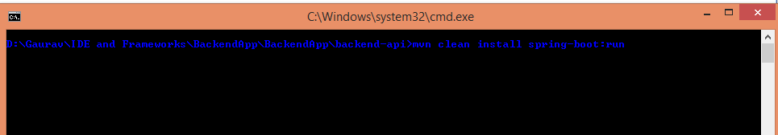

mvn clean install spring-boot:run

1. Open Postman and access below url

<http://localhost:8081/backendapi/Helsinki>

where Helsinki is city name and we are passing it as a request parameter.

1. We need to pass 4 values as a part of headers.

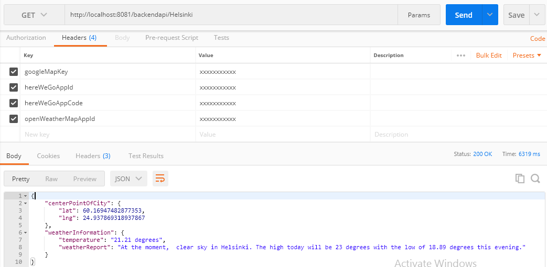

Please create account on respective API’s site, get your codes and appIds.